Recognizing Nondominated Coteries and wr-Coteries by Availability
Tyu-Chen Kuo and Shing-Tsaan Huang
IEEE Transactions on parallel and distributed systems, VOL. 9, NO. 8, Aug. 1998, pp. 721-728
Abstract
In this paper, authors demonstrate a way to recognize nondominated coteries using availability. By evaluating the availability of a coterie instead of using a formal proof, the coteries can be recognized as a nondominated coterie or not.
- Introduction
- Preliminaries
A coterie C under U is dominated iff ∃ H ⊆ U such that the following properties are satisfied:
[P1](∀ Q ∈ C, Q ⊄ H)
[P2]( ∀Q ∈ C, H ∩ Q ≠ ∅)
- Availability of ND Coteries
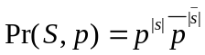 then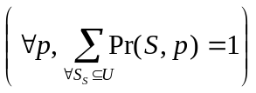
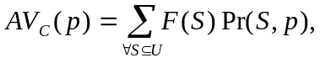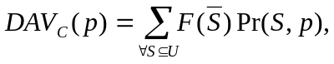
where F(S) = 1 if (∃ Q ∈ C, Q ⊆ S)

A coterie C is ND iff (∀ p, AV_{C}(p) + DAV_{C}(p) = 1).

A coterie C is ND iff AV_{C}(p) = 0.5 when p = 0.5
- Properties of ND wr-Coteries
Similar with the section 3.
- Conclusions

Created by : Kwo-Tsung Tseng
Date : Apr. 20, 1999

